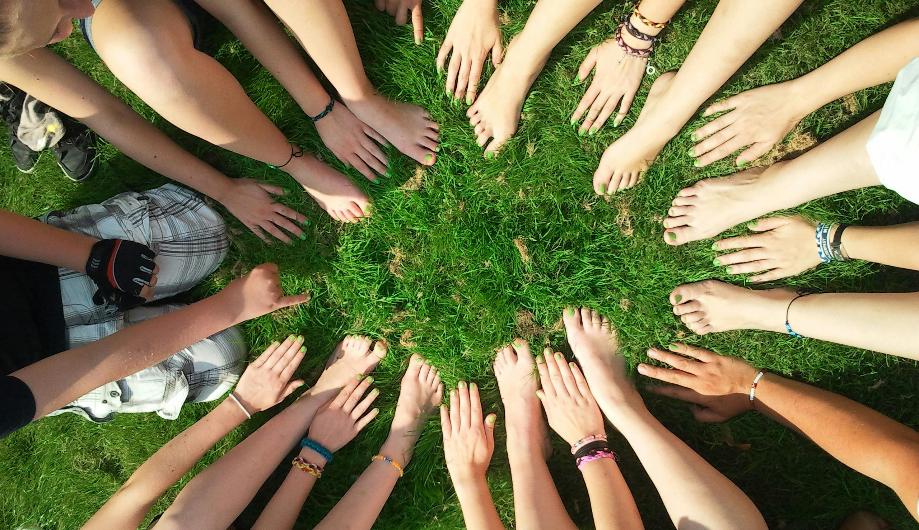
<Nonprofit Organization Name>

Annual Report 2024
<Name>
Prepared by:

Chairperson’s Message
Dear Friends and Supporters,
As we reflect on the past year, I am filled with gratitude and pride for the incredible journey we have undertaken together as a community. The [Nonprofit Name] has always stood as a beacon of hope, driven by our unwavering commitment to [mission/goal of the nonprofit].
In the face of unprecedented challenges, our collective resilience shone brighter than ever. Despite the obstacles presented by [mention any challenges faced, e.g., the pandemic, economic downturn], our team remained steadfast in our dedication to serving those in need. Whether it was through [list specific initiatives, programs, or projects], each action we took was guided by our core values and the belief that every individual deserves access to [mention your nonprofit's key services or goals].
I am immensely grateful for the support of our donors, volunteers, staff, and partners who stood by us every step of the way. Your generosity and commitment have been the driving force behind our success, empowering us to make a tangible difference in the lives of countless individuals and communities.
Looking ahead, we are filled with hope and determination to build upon our achievements and continue striving for positive change. Together, we will embark on new initiatives, forge stronger partnerships, and explore innovative solutions to address the evolving needs of those we serve.
As we navigate the path forward, I invite each of you to join us in our mission. Together, we can create a brighter, more inclusive future for all.
Thank you for your unwavering support and belief in our cause.
With gratitude,
[Your Name] Chairperson, [Nonprofit Name]

Sincerely,
<CHAIRPERSON’S NAME>
Chairperson of the Board
<SIGNATURE>

About the Organization



Mission
Our mission is to bridge the educational gap in underprivileged areas by offering comprehensive learning programs, resources, and support to ensure every child has the chance to succeed academically and personally.

Vision
Our vision is a future where all children, regardless of their background, have access to quality education that empowers them to reach their full potential and contribute positively to society.

Program & Activities

Program 1 Name

The Future Scholars Tutoring Program provides personalized academic support to underprivileged middle and high school students. Through one-on-one tutoring sessions and small group workshops, we help students improve their grades, build confidence, and develop essential study skills, ensuring they are well-prepared for higher education and future career opportunities.


Program 2 Name

The Green Earth Restoration Initiative focuses on the rehabilitation of degraded lands through community-driven reforestation projects. By planting native trees, restoring habitats, and educating local communities on sustainable practices, this program aims to combat climate change, preserve biodiversity, and promote environmental stewardship for a healthier planet.

Program 3 Name

The Healthy Hearts Community Clinic offers free medical services to low-income families and individuals without access to healthcare. Our volunteer healthcare professionals provide routine check-ups, preventive care, and health education, aiming to improve overall health outcomes and quality of life within our community.

Financial Statements

The following are the organization’s statements for the year 2024

Summary

In the past year, our nonprofit organization has demonstrated strong financial performance, as illustrated in our "Annual Income vs. Expenses" chart. Our total income reached $131,500.00, comprising: Donations: $112,000.00, Program Fees: $15,000.00, Other Income: $4,500.00

Our primary expenses amounted to $50,000.00, including: Food/Shelter: $38,000.00 and Other Expenses: $12,000.00

This financial overview highlights a positive balance, with income significantly exceeding expenses. The surplus ensures we can reinvest in our programs, expand our reach, and continue providing essential services to our community. The generous support from our donors and the dedication of our team have been crucial to achieving these results, setting a strong foundation for the coming year.

Impact & Outcomes

The year 2024 has been exceptional for our organization, marked by several key accomplishments, including:

Outcome 1

This year, we successfully launched an after-school tutoring program that reached over 300 students in underserved communities, significantly improving their academic performance and confidence.

Outcome 3

We spearheaded a major reforestation effort, planting 10,000 native trees in deforested areas. This initiative not only enhanced local biodiversity but also engaged 500 community volunteers in sustainability practices.

Outcome 2

Over new community health clinic provided free medical services to over 1,000 individuals, offering preventive care, health education, and essential treatments and greatly improved the well-being of our beneficiaries.

Board & Staff
<FIRST NAME>
<LAST NAME>
<POSITION>
<FIRST NAME>
<LAST NAME>
<POSITION>
<FIRST NAME>
<LAST NAME>
<POSITION>
<FIRST NAME>
<LAST NAME>
<POSITION>
<FIRST NAME>
<LAST NAME>
<POSITION>
<FIRST NAME>
<LAST NAME>
<POSITION>
<FIRST NAME>
<LAST NAME>
<POSITION>
<FIRST NAME>
<LAST NAME>
<POSITION>

Our Team

